This list is provided by Joseph Burrascano, MD, Internist, (Ret.)
Board of Directors, International Lyme & Associated Diseases Society
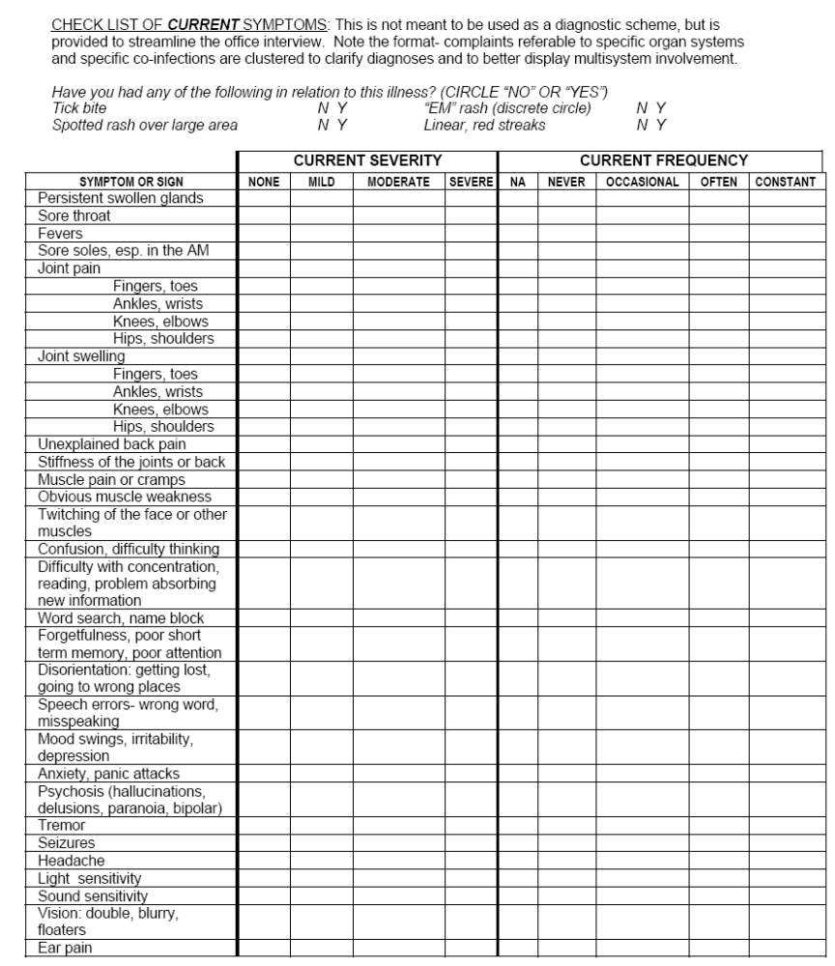

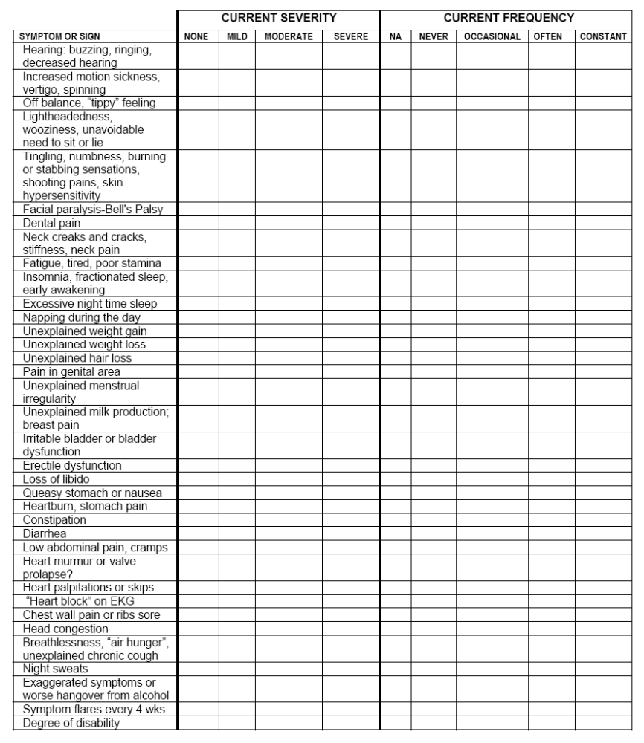
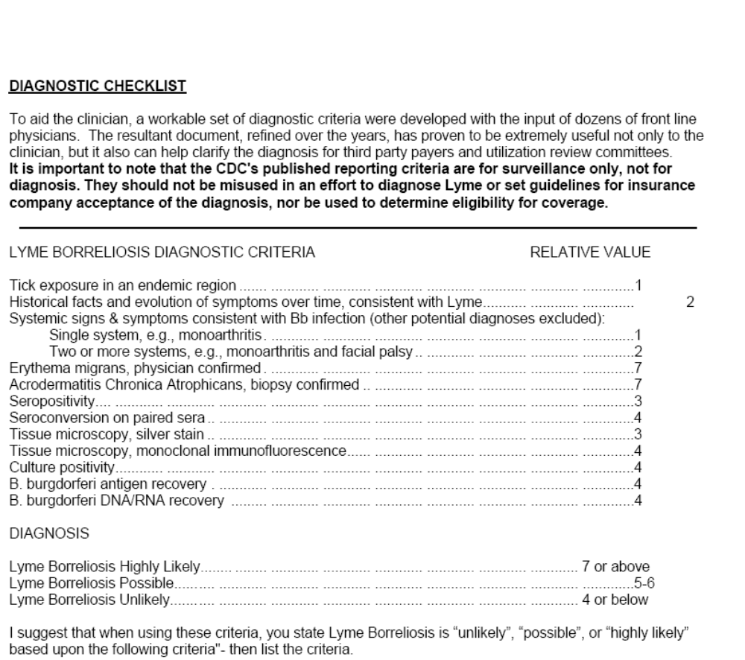

Reprinted with permission from ADVANCED TOPICS IN LYME DISEASE Fifteenth Edition September, 2005 DIAGNOSTIC HINTS AND TREATMENT GUIDELINES FOR LYME AND OTHER TICK BORNE ILLNESSES
JOSEPH J. BURRASCANO JR., M.D. Copyright, September, 2005

For complete Burrascano Guidelines:
http://www.lymediseaseassociation.org/drbguide200509.pdf

