EVIDENCED BASED PRACTICE OF LYME DISEASE
October 6, 2012
1:00pm – 3:00pm
Health Research Center Auditorium
The Medical College of Wisconsin 8701 Watertown Plank Road Milwaukee, WI 53226

This activity is designed for Pediatricians, Family Medicine, General Internists, Infectious Disease and Neurologists

Learning Objectives: Upon completion of the program, participants should be able to:
- Identify patients who present with typical and unusual presentations of Lyme disease and associated diseases
- Describe the mechanisms of virulence and persistence by the Lyme spirochete
- Select the best method to evaluate patients with Lyme and co-infections
- Select the evidence-based treatment for various clinical scenarios for the differing clinical presentation to achieve a good outcome
- Identify barriers to implement divergent Lyme disease guidelines and how to translate the new guidelines into practice

Dr. Daniel Cameron graduated from the University of Minnesota followed by residencies at Beth Israel Medical Center and Mt. Sinai School of Medicine in New York. Dr. Cameron is widely recognized for conducting epidemiologic research while practicing medicine. He has been viewed as a pioneer in Lyme disease as an author of practice guidelines, analytic reviews, and clinical trials. He has published 9 peer reviewed articles based on his research in the past 5 years.
Dr. Cameron’s has led ILADS, the International Lyme and Associated Diseases Society, to new heights as its president from 2007 to 2009. He has testified as an expert on Lyme disease for legislation in Connecticut, Massachusetts, and Pennsylvania for physician’s rights to diagnose Lyme disease using clinical judgment without state interference. He has been interviewed as an expert on the NBC today show, Good Morning America, Fox News, Sirius radio and in newspapers.
He currently sees patients in his private practice in Mt. Kisco, New York while continuing his research and writing. He maintains the website www.LymeProject.com.
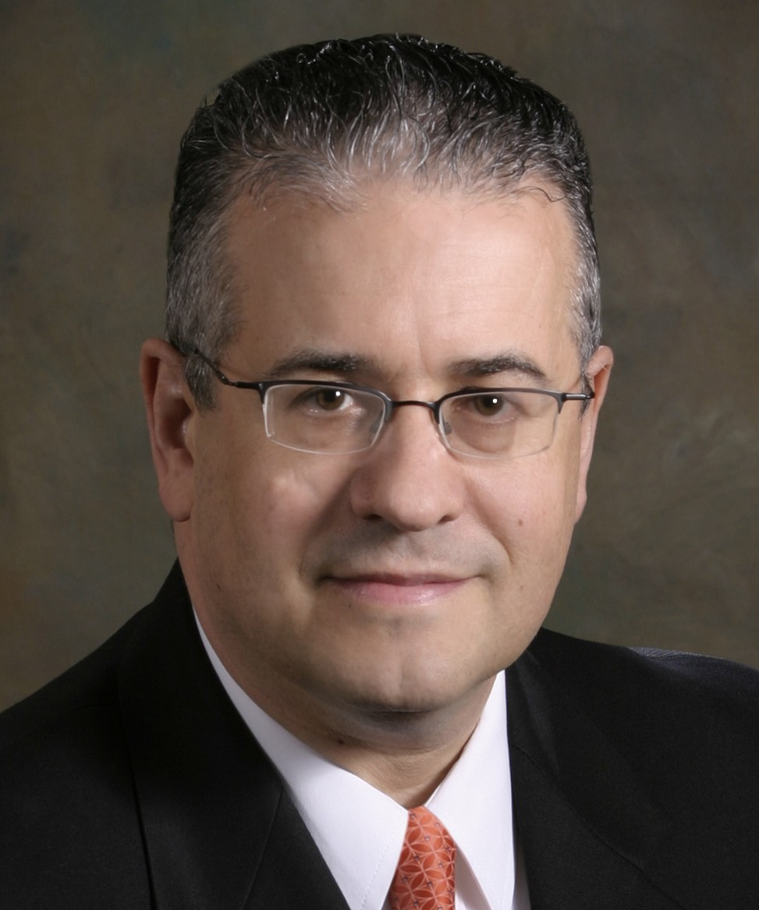

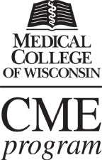

Accreditation Statement:
The Medical College of Wisconsin is accredited by the Accreditation Council for Continuing Medical Education to provide continuing medical education for physicians.

Designation of Credit Statement:
The Medical College of Wisconsin designates this live activity for a maximum of 2.0 AMA PRA Category 1 Credit(s) ™. Physicians should claim only the credit commensurate with the extent of their participation in the activity.

RSVP and Special Needs Contact: Jennifer Christie (920) 246-2164 or jchristie000@ameritech.net

