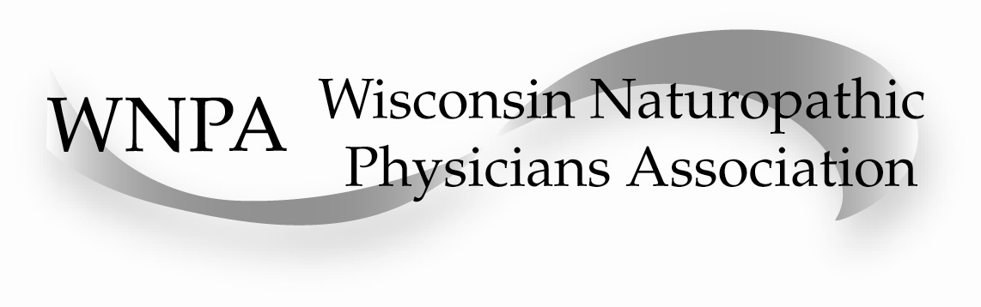
December 3, 2011

Dear Potential Vendor,

This coming year, March 10 and 11, 2012, the Wisconsin Naturopathic Physicians Association (WNPA) will be hosting a Midwest regional continuing education conference in Madison, Wisconsin. We have invited naturopathic physicians from Wisconsin, Illinois, Iowa, Minnesota, Michigan, Ohio, Indiana and Kentucky, along with other health care practitioners from throughout the region, to come together to enhance our knowledge and skills, and to build community. This year the conference is a two day event, a full day on Saturday, with Sunday ending at 3 p.m.
There is great interest in this regional conference, and we are expecting between 100 and 150 attendees.

The topic of the conference will be Lyme Disease, a complex, challenging disease process that is significantly affecting the health and well being of people in many areas of the country. According to the CDC statistics in 2010, Wisconsin had the third highest report of Lyme Disease, just behind New Hampshire and Connecticut, closely followed by Vermont, Maine, Massachusetts, and New Jersey. It is a health care problem that demands our fullest attention, and we are gathering some of the top Lyme experts in the region as speakers for this conference.

Last year we had a very successful gathering, which included a distinguished group of those vendors that provide the naturopathic profession with the dispensary and laboratory tools of our trade. We would like to invite you, as a returning vendor or a first time vendor, to participate in this year’s regional conference by having a table, displaying your products and services, meeting our attendees, and being a part of our community.

The location will be:
The Pyle Center, University of Wisconsin campus
702 Langdon Street, Madison, WI 53706, 608 262-1122
Parking is available at State Street Campus Ramp, 400 N. Lake St., 2 blocks S. of the Pyle Center
There is a loading dock on the back side of the Pyle Center for short term loading and unloading.

If you need overnight accommodations in Madison, a block of rooms has been set aside at the Lowell Center, a guest house (hotel) affiliated with the Pyle Center. Cost for a single room no view is $89, single room with a view $105, double room no view $101, double room with a view $117. You can view details on line, http://conferencing.uwex.edu/lodging.cfm, and reservations can be made directly through the Lowell Center. Please let them know you are part of the WNPA block. Other hotels in the area are also available.

The cost to have a table in the vendor room is $450. Tables and chairs are provided, without drapes. I am working to finalize the conference schedule, which will have ample break times for attendees to visit the vendor room. I will send the finalized schedule for the weekend once I complete it. We will also be hosting a vendor appreciation hour at the end of the lecture day on Saturday, offering an additional opportunity for you to interface with the attendees.

All breaks throughout the conference weekend will feature refreshments served right in the vendor room, which will assure visibility and accessibility. If your company is interested in sponsoring one of the breaks with an additional $250 donation, we will feature your company with an announcement just before that break, as well as include literature or product samples from your company in the conference bags that will be given to each attendee.

Lunch will be catered by the UW Extension. They request that no carry-in food be brought into the Pyle Center. Lunch is included for all vendors.

If you would like to participate in this years WNPA hosted regional naturopathic medicine conference by having a vendor table, please contact me, Robin DiPasquale, by phone 608 203-5890 or by e-mail robindipasquale@yahoo.com to reserve your space. Checks can be made payable to WNPA and mailed to me directly at:
Red Lotus Healing Arts
7818 Big Sky Drive, Suite 209
Madison, WI 53719
You will also be able to pay on the Wisconsin Naturopathic Physicians Association website, www.wisconsin-nd.org as soon as I get the web master to set up the link.

You, our vendors, are a very important part of our success as practicing naturopathic physicians. I hope you will join us at this gathering of eight Midwest states so that we can celebrate together what we bring to the health and well-being of the human community.

Thank you, and we hope to see you on March 10 and 11, 2012.

Sincerely,

Robin DiPasquale, ND, RH (AHG)
WNPA Coordinator for the annual CE conference

